ENGR 219: Numerical Methods Name: Syeduzzaman Khan

Computer Project# 2

5 a)

function [root] = newton_khan(fcn_name,guess,nmax)

% Newton root finding tech, eng 219

% function returns function roots

% Parameters: atol= absoluate tolerance, rtol=relative tolerance, root= resutl,

% display

disp (' Iter Value Fcn Delta')

% parameter initilaiation

atol=1e-8;

rtol=1e-4;

root=0;

xnew=guess;

fnew=fcn_name(xnew); % call interest cal. function

deltax=guess*rtol+atol; % act as derivative

for i=1:nmax

xold=xnew;

fold=fnew;

xnew=xold+deltax;

fnew=fcn_name(xnew);

fprime=(fnew-fold)/(xnew-xold);

deltax=-fnew/fprime;

if abs(deltax)/(xnew+atol)<rtol

root=xnew+deltax;

disp( [i xnew fnew deltax ])

break

else

disp( [i xnew fnew deltax ])

end

end

if root==0

%%% single quote for string

disp(' warning: if root=0, plz check your function ');

end

end

5 b)

# Figure of 8.22

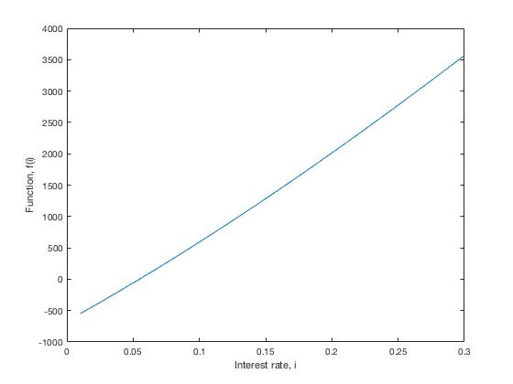

Figure 1: Plot of interest incurring function. The function is plotted for interest rate, i=0 to 0.03 range and the function convergence at 0.0547. The root of the function is 0.0547.

# Figure of 8.22

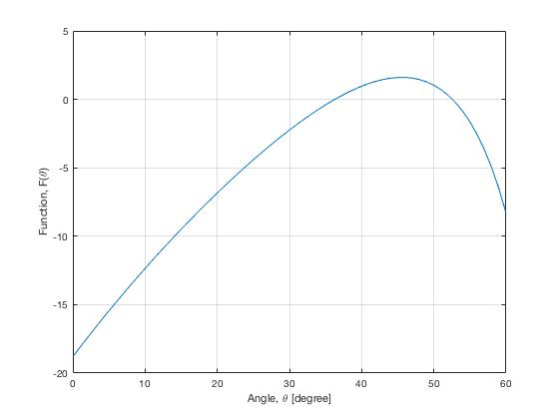

Figure 1: Plot of thrown ball trajectories function. The function is plotted for angle, theta=0 to 60 range and the function convergence at 36.2274 and 52.5768. The number of roots of the function could be infinite but those two numbers can be used as initial guess.

Appendices:

# 8.22-> Interest calculation function

function [fi] = interest_function_khan(i)

% [fx] = interest_function_khan(i) evaluates interest rates

% input: i interest rate

% output: [fx]=returns functions

%Parameters: P=present worth in USD, A=annual payment in USD, n= years

P=20000;

A= 4000;

n=6;

fi=(P.*((i.*(1+i).^n)./((1+i).^n-1)))-A ;

end

# 8.37-> Thrown ball trajectories function

function [ftheta] = trajectories_function_khan(theta)

% [fx] = trajectories_function_khan(theta) evaluates trajectories

% input: theta angle in degree

% output: [fx]=returns functions

%Parameters: v_0=velocity in m/s, x=distance in m, y_0= intial diatcne in

%m, y= distance to ball in m, g= gravitational acceleration in m/s^2

v_0=20;

x=40;

y_0=1.8;

y=1;

g=9.8;

theta=pi/180*theta;

ftheta=(tan(theta).*x)-((g.*x.^2)./(2.*v_0.^2*cos(theta).^2))+(y_0-y);

end

# plot m file

% Plot functions

close all

% 1. plot interest function

i=0:0.01:0.3;% interest range range

f = interest_function_khan(i);% function call

figure;

plot (i,f)

xlabel("Interest rate, i")

ylabel("Function, f(i)")

% 2. plot trajectories

theta=0:1:60;

f_t=trajectories_function_khan(theta);

figure;

plot (theta,f_t)

xlabel("Angle, \theta [degree]")

ylabel("Function, F(\theta)")

grid on;